**Weekly Report 10/28**

**MSiA-400 Group 1** : Ellen, Henry, Ishu, Enzo

Tasks Accomplished:

* Discussed the business questions we came up last week and narrowed the candidateds down to two questions:
  + Store clustering: how can we cluster the stores into different groups, for valid performance comparisons and benchmarking?
  + Classification: Will an item category make money or lose money?

(We plan to complete EDA first and then finalize the topic based on the information).

* Simple data cleaning.
* Exploratory Data Analysis.

Downbelow are some examples from EDA: The first two graphs are based on the 10000 randomly selected samples from the trnsact data.

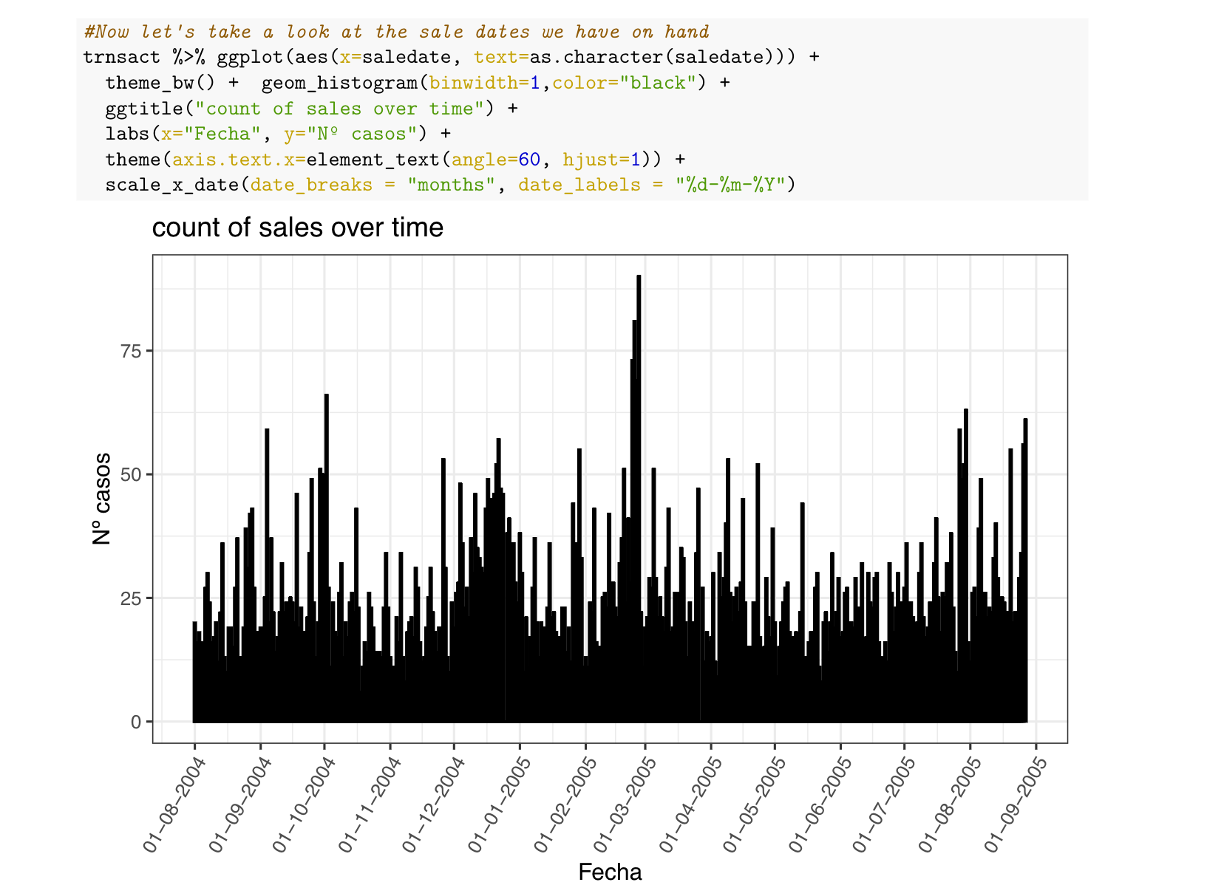

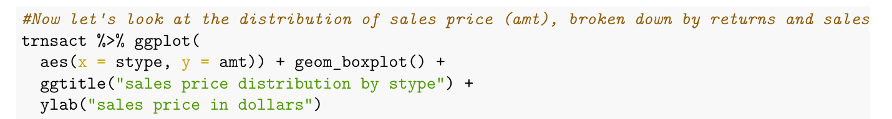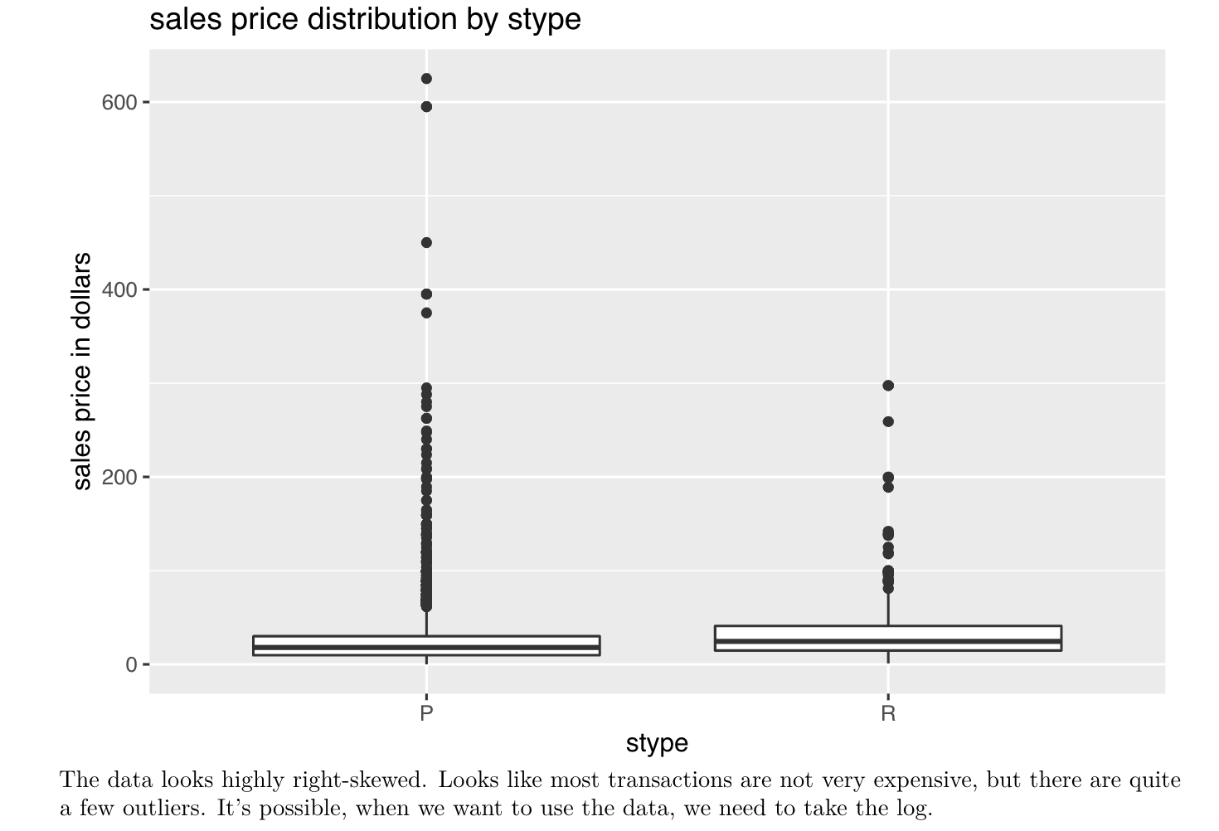

The following two graphs are from sksinfo data set:

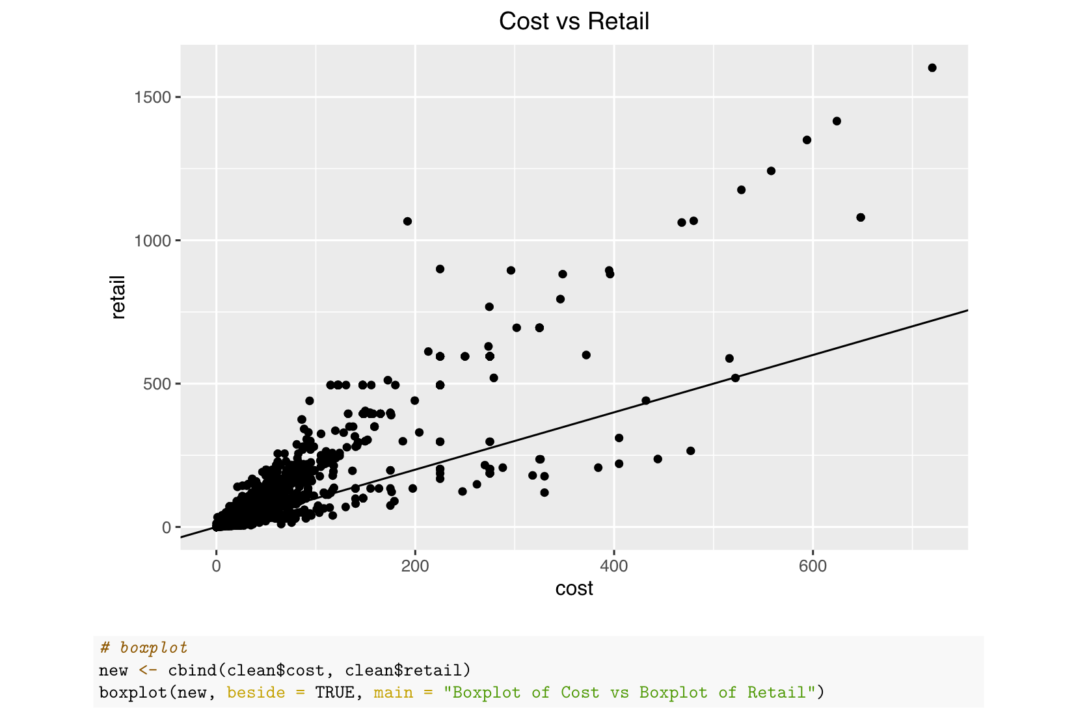

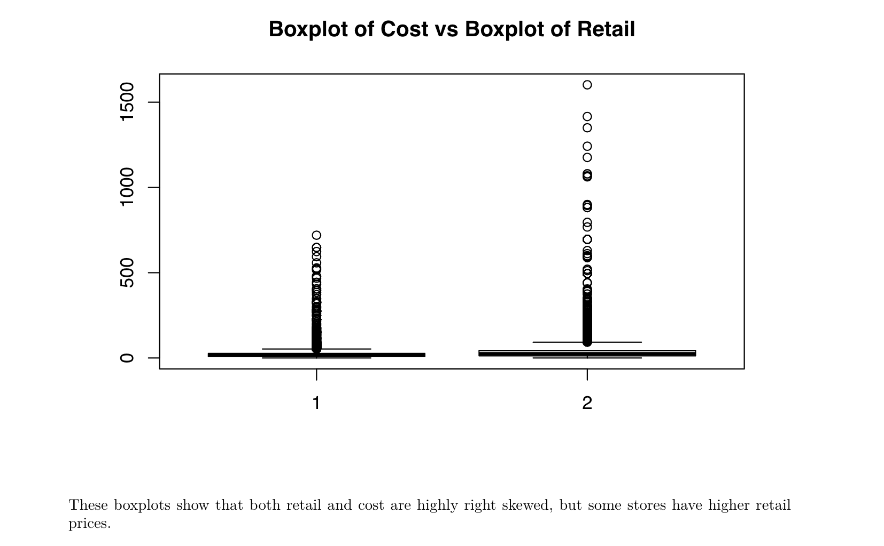

* Prepare for the 400 Exam.

Plans for Next Week:

1. Continue data cleanning.
2. Further exploratory data analysis, then try to finalize the business question.
3. Think about the potential machine learning model for the project.